Module 6 – Portfolio Milestone

Author – Rue Green

Screen shot of initial program running with empty shopping cart:

Screen shot of adding two items to the cart and printing the total cost and item description:

Screen shot of removing an item from the shopping cart. If not found showing message for that:

Screen shot of updating an item in the shopping cart, if not found showing message for that:

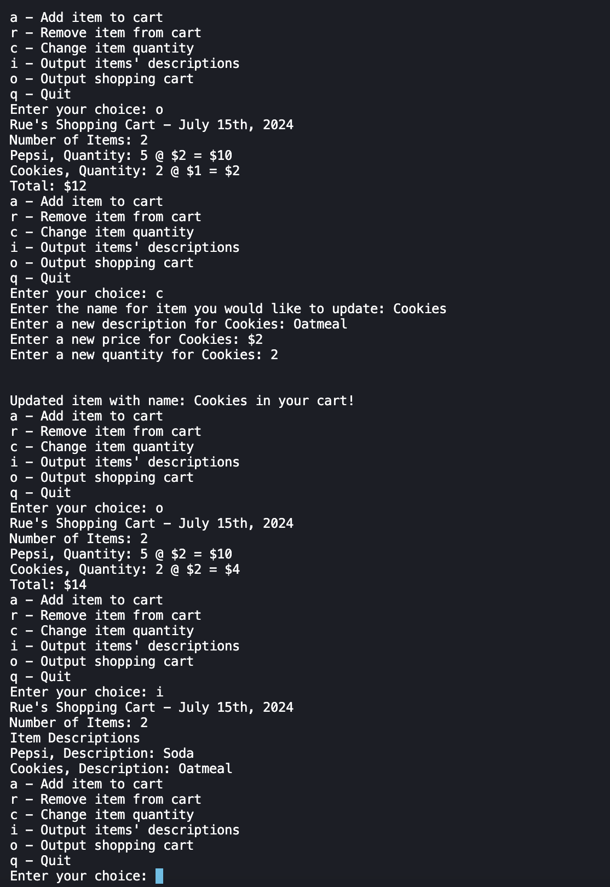

Screen shot of quitting the program:

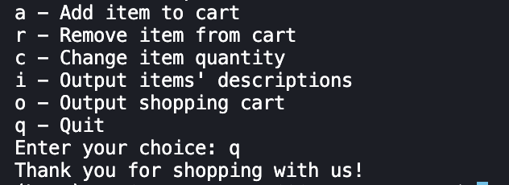

Git hub Public Repo:

Root Public URL: <https://github.com/ruegreen/CSC500/tree/main>

Module 6 URL: [https://github.com/ruegreen/CSC500/tree/main/Module 6](https://github.com/ruegreen/CSC500/tree/main/Module%206)